A
MINI PROJECT REPORT
On

“ Blood Bank Management System ”
Submitted to
MIT Art, Design & Technology University
in partial fulfilment of tshe requirements for the award of the degree of
BACHELOR OF TECHNOLOGY
IN
ELECTRONICS AND COMPUTER ENGINEERING

Submitted by
Group Code: : ECO2425UGMP-07

ATHARV LAD MITU22BTEC0017
ANUJA CHITODE MITU22BTEC0011
SANSKRUTI ZASKAR MITU22BTEC0075

Under the Guidance of
PROF. RUPALI ITHAPE



DEPARTMENT OF ELECTRONICS AND COMMUNICATION ENGINEERING
SCHOOL OF ENGINEERING AND SCIENCES, MIT ADT UNIVERSITY
RAJBAUG, LONI KALBHOR, PUNE – 412201
May 2025

DEPARTMENT OF ELECTRONICS AND COMMUNICATION ENGINEERING
SCHOOL OF ENGINEERING AND SCIENCES, MIT ADT UNIVERSITY
RAJBAUG, LONI KALBHOR
PUNE – 412201

CERTIFICATE

This is to certify that the Mini Project report entitled
“BLOOD BANK MANAGEMENT SYSTEM”

Submitted by

ATHARV LAD MITU22BTEC0017
ANUJA CHITODE MITU22BTEC0011
SANSKRUTI ZASKAR MITU22BTEC0075

is a bonafide work carried out by them, under the supervision of Prof. Rupali Ithape and it is submitted towards the partial fulfilment of the requirement of MIT Art, Design and Technology University, Pune for the award of the Bachelor of Technology in Electronics and Computer Engineering.

Prof.  Guide | Prof.  Mini-Project Co-ordinator
Prof. Dr.  I/c HoD, ECE Dept. | Prof. Dr. Virendra Shete  Director

Chairperson / Examiner
Place: Pune
Date: 19/05/2025

DECLARATION
We hereby declare that the Mini project entitled “BLOOD BANK MANAGEMENT SYSTEM” submitted towards the partial fulfilment of the requirement of MIT-ADT University, Pune for the award of the Bachelor of Technology in Electronics and Computer Engineering is a record of bonafide work carried out by we under the supervision of Prof. Rupali Ithape, Department of Electronics and Communication Engineering, School of Engineering and Sciences.
We further declare that the work reported in this report has not been submitted and will not be submitted, either in part or in full, for the award of any other degree or diploma in this institute or any other institute or university.

Place: Student Names and Sign
Date: ATHARV LAD
ANUJA CHITODE
SANSKRUTI ZASKAR

ACKNOWLEDGMENT

We express our profound thanks to Guide Prof. Rupali Ithape, Electronics and Communication Engineering, School of Engineering and Sciences MIT-ADT University, Pune for her expert guidance, encouragement and inspiration during this Mini project work.
We are very thankful Prof. Dr. Sachin Patil, Mini-Project Co-ordinator, Electronics and Communication Engineering Department for his guidance and all kinds of help to complete our work.
We are sincerely thankful Prof. Dr. Sachin Takale, Program Head, Electronics and Computer Engineering for his valuable guidance and support throughtout our mini project.
We also express thanks to Prof. Dr. Gopal Gawande , I/c Head, Department of Electronics and Communication Engineering, for being constant source of inspiration throughout the execution.
We are grateful to Prof. Dr. Virendra Shete, Director, School of Engineering and Sciences, MIT-ADT University, Pune, for providing us the facilities to carry out this work.
We also thank all the faculty members in the department for their support and advice. We are very much grateful to our Parents for their immense love, affection, help, cooperation and encouragement to complete this course.
Finally, a special thanks to all our classmates and friends who helped and encouraged us to complete successfully our Mini project work.

Student Names

ATHARV LAD
ANUJA CHITODE
SANSKRUTI ZASKAR

ABSTRACT
Blood Bank Management System is a web-based application. Through this application anyone interested in donating blood can register through this website. Moreover, any general patients can request blood through this site. Admin is the main authority who can do addition, deletion and modification if required. The project has been planned to be having the view of distributed architecture with centralized storage of the database. This website has been developed using the HTML, CSS, JavaScript and bootstrap for the Front End and for backend I have used My SQL Server and PHP.
By automating key processes and providing real-time data access, the system minimizes manual errors, reduces paperwork, and enhances the coordination between hospitals, donors, and blood banks. The implementation of this system contributes to faster decision-making, improved inventory control, and overall better healthcare services. This project incorporates database management, user authentication, and reporting features, making it a robust and user-friendly application for daily blood bank operations.
It maintains a comprehensive database of donors, recipients, blood inventory, and transaction history, allowing for quick access to crucial data during emergencies. Key features include donor registration, blood request processing, compatibility checking, inventory monitoring, and automated notifications. The system reduces manual errors, improves data accuracy, and ensures timely availability of blood, thereby contributing to life-saving healthcare services. This project applies core principles of software engineering and database management to address the critical needs of blood supply management in medical institutions.
The system provides role-based access for administrators, hospital staff, and donors. Donors can register, view donation history, and receive alerts for upcoming donation eligibility. Administrators can manage donor details, update blood stock levels, verify incoming blood donations, and track requests from hospitals. The system also includes a search feature to quickly locate specific blood types and filter by availability, location, or donor eligibility.
This project is designed to bridge the gap between blood donors and recipients by maintaining a centralized and dynamic database that tracks donor eligibility, donation history, blood inventory, and request processing. It streamlines various functions including donor registration, blood group classification, stock monitoring, request allocation, donor notification, and report generation. Moreover, it provides functionalities for user authentication and access control to safeguard sensitive medical and personal information.

PHOTOGRAPH OF THE PROJECT

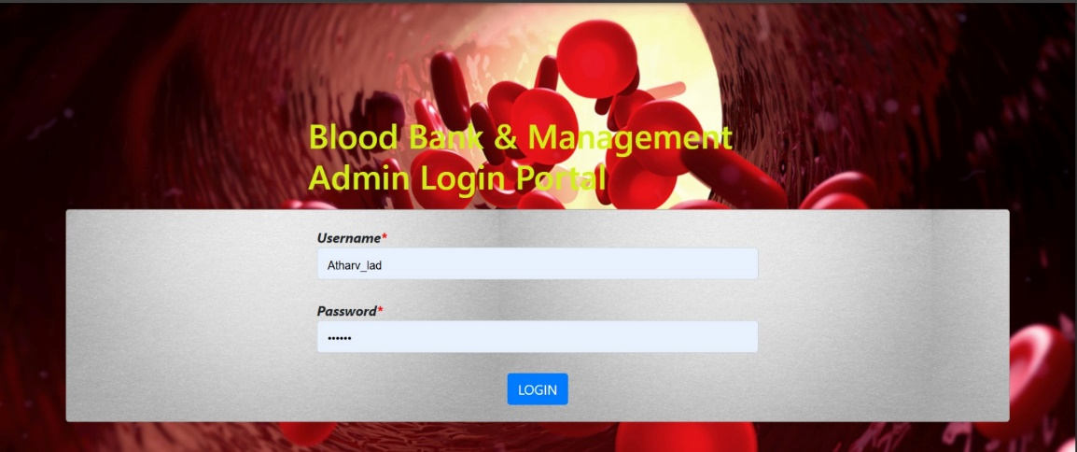
Fig 1.Admin Login Page

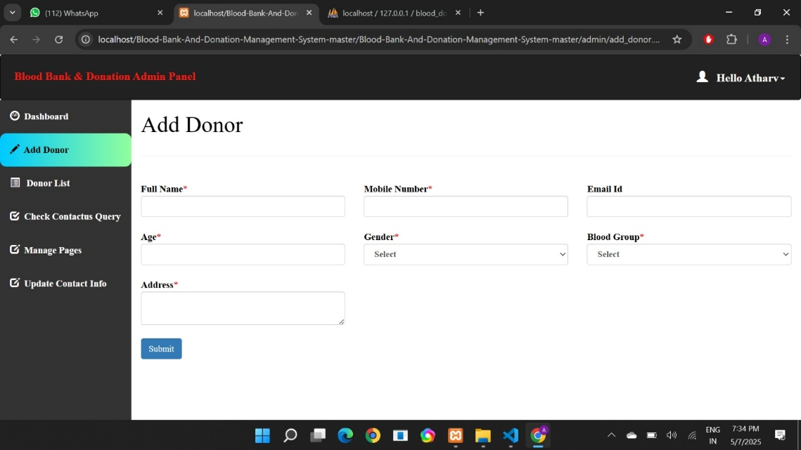

Fig 2.Donor form

TABLE OF CONTENTS

ABSTRACT i
PHOTOGRAPH OF THE PROJECT ii
TABLE OF CONTENTS iii
LIST OF FIGURES iv
LIST OF TABLES iv
ABBREVIATIONS v
Chapter 1 1
INTRODUCTION 7
1.1Introduction 7
1.2 Organization of the Report 7
1.3 Closure 8

Chapter 2 9
LITERATURE REVIEW 9
2.1 Introduction 9
2.2. Review of literature 10
2.4 Summary of the literature 10
2.4 Identification of Gaps/Scopes of Work 10
2.5 Problem Statement 10
2.6 Objectives 11
2.7 Closure 11
Chapter 3 12
METHODOLOGY 12
3.3 Methodology flow diagram 13
3.4 Closure 14
CHAPTER 4 15
RESULTS AND DISCUSSIONS 15
4.1 Introduction 15
4.2 Key points in Results and Discussion 15
CHAPTER 5 16
CONCLUSION AND FUTURE SCOPE 16
5.1 Conclusion 16
5.2 Future Scope 16
Reference 17
APPENDIX I 18
PROJECT BASED AWARDS AND ACHIEVEMENTS (if any) 18
PATENT 18
COPY RIGHT 18
LIST OF PUBLICATIONS 18
AWARDS/ACHIEVEMENT IN ANY COMPETITIONS 18
APPENDIX II 19
PROJECT BASED OUTCOMES 11

LIST OF FIGURES

Fig. No. | Name of the Figure | Page No.
1 | Admin Login Page | 2
2 | Donor form | 2
3 | Methodology Flow Diagram | 14

ABBREVIATIONS
1. BBMS : Blood bank management system
2. WHO : World health organizations
3. DBMS : Database management system
4. SQL : Structured query language
5. ID : Identification
6. API : Application Programming Interface
7. HTTP : Hypertext markup language
8. CSS : Cascading Style Sheets
9. JS : Java script
10. PHP : Hypertext Preprocessor

CHAPTER 1

INTRODUCTION

Introduction
A Blood Bank Management System is a digital solution designed to manage and streamline the operations of blood banks. The primary objective of such a system is to efficiently handle tasks related to blood donations, inventory management, donor records, and blood requests. Blood banks are crucial in healthcare systems, as they store and distribute blood to hospitals and patients in need, particularly in emergencies, surgeries, and treatments for various health conditions.
Traditionally, blood banks have relied on manual systems to track and manage blood donations and inventories. These manual processes are time-consuming, prone to human error, and often lead to delays in matching blood units to urgent requests. Mismanagement of blood stocks—such as expired blood, incorrect labeling, or missing records—can have severe consequences, including the wastage of valuable blood and failure to meet patient needs.
With the rise of digital technology, many blood banks are now transitioning to automated systems to improve efficiency and reduce human error. A Blood Bank Management System can help in storing donor information, tracking blood units, sending alerts when stock levels are low or when blood is about to expire, and enabling hospitals to easily place requests for required blood types.

1.2 Organization of the Report
The structure of this report is organized into five main chapters, each focusing on different aspects of the Blood Bank Management System mini project. Below is a brief overview of each chapter:
Chapter 1 introduces the Blood Bank Management System, explaining its importance and objectives.
Chapter 2 provides a literature review, highlighting existing research, challenges, and identifying research gaps.
Chapter 3 details the methodology used for system design and development.
Chapter 4 presents the results of the system with discussions on its functionality and effectiveness.
Chapter 5 concludes the report and explores the future scope of improvements and potential expansions of the system.

1.3Closure
The Blood Bank Management System aims to overcome the limitations of traditional methods by offering a faster, more accurate, and secure way to manage blood-related data. This project is an important step toward building a more responsive and efficient blood management process that benefits both patients and healthcare providers.

CHAPTER 2

LITERATURE REVIEW

2.1 Introduction
A Blood Bank Management System is a software-based application that helps manage blood donations, storage, and supply in an organized and efficient way. Many researchers and developers have worked on improving how blood banks operate using technology.

2.2. Review of literature
1. A. Joshi and M. Deshmukh, in their study "Design and Implementation of Blood Bank Management System" (assumed year: 2021), presented a desktop-based application designed for hospital use. The system, developed using C# and SQL Server, includes features like searchable blood group availability, blood bag tracking, and stock monitoring. These additions significantly improve traceability and stock control. Traditional blood bank systems offered no clear method to track individual blood bags, often leading to misplacement or lack of accountability. Manual stock records were another issue, frequently being outdated or incorrect. This implementation ensures better oversight and accurate data for hospital administrators.
2. Rohan Akash et al.focused on creating a web-based platform to improve donor and inventory management. Built using HTML, CSS, PHP, and MySQL, the system enables online donor registration, automated inventory tracking, and alerts for expiring blood units. These features directly address the inefficiencies of traditional systems, which depended on manual data entry, paper records, and often overlooked blood expiry dates. The inclusion of expiry alerts is particularly useful for reducing waste, a common problem in conventional blood banks where expired units might be unknowingly used or discarded late.
3P. Patel and R. Mehta in their research paper titled "Blood Bank Management System with Emergency Blood Locator" (assumed year: 2020), proposed a modern approach to enhance emergency responsiveness in blood donation services. The system integrates hospitals with blood banks and introduces a real-time emergency blood locator through a mobile application. Developed using Android (Java) and Firebase, this solution allows users to quickly locate nearby blood banks that have the required blood type, especially in emergencies. Traditional blood bank systems lacked such integration and relied on manual calls and paperwork during critical situations, leading to delays and miscommunication.
2.3 Summary of the literature
The literature shows that Blood Bank Management Systems have greatly improved with the use of technology. Earlier manual systems were slow and error-prone, but modern software solutions help store and manage donor data, monitor blood stock, and handle blood requests more effectively. These systems also improve communication, data security, and overall efficiency. Web and mobile apps further enhance accessibility and coordination between donors, hospitals, and blood banks.

2.4 Identification of Gaps/Scopes of Work
Even though many systems have been developed, there are still some gaps:
Lack of Standardization Across Systems : Each research paper uses different platforms and tools (Android, web-based, desktop, IoT), but there's no unified standard for integration across multiple hospitals or blood banks.
No Real-Time Donor Location and Tracking Integration : While emergency locators exist (e.g., Patel & Mehta), no system includes GPS tracking of donors or live availability updates based on current location and eligibility status.
Lack of Emergency and Disaster Preparedness Modules : No system specifically addresses large-scale emergency scenarios (e.g., accidents, natural disasters, or pandemics) with priority-based distribution or emergency protocols.

Scope of Work
- Develop a simple, user-friendly system for managing blood donors and stock.
- Add alerts for low stock and donor reminders.
- Ensure data security and proper login access.
- Make the system accessible through web or mobile.

2.5 Problem Statement
Blood is a critical resource in saving lives, especially during surgeries, emergencies, and treatment of serious illnesses. However, many blood banks still rely on manual processes to manage donor records, blood stock, and blood requests. This manual system often leads to delays, human errors, data loss, and poor coordination, especially during emergencies when every second counts.
There is no quick way to check available blood types, track the expiry of blood units, or identify eligible donors. In many cases, blood is wasted due to expiry, or lives are lost due to unavailability, simply because the system is not efficient. Additionally, manual systems are not scalable and make it hard to maintain accurate, up-to-date records, especially when the volume of data grows.
Another major issue is lack of security in managing sensitive donor information, and limited accessibility as many manual or outdated systems cannot be accessed remotely or shared across hospitals.

2.6 Objectives
- To design a user-friendly blood bank management system.
- To store and manage donor and blood stock information.
- To generate alerts for low blood stock and eligible donors.
- To ensure secure access using login features.
- To allow hospitals to request and track blood units.

2.7 Closure
The reviewed literature highlights the critical role of blood bank management systems in ensuring the efficient collection, storage, and distribution of blood. Various existing systems demonstrate the potential of digital platforms in reducing human error, enhancing traceability, and improving communication between donors, hospitals, and blood banks.

Chapter 3

METHODOLOGY
3.1 Introduction
The purpose of this Blood Bank Management System is to create an efficient, reliable, and secure platform to manage donor details, blood inventory, and blood requests. The methodology used in this project focuses on designing and implementing a user-friendly software system that replaces manual record-keeping and speeds up the overall process in a blood bank.
3.2 Methodology details
The development of the Blood Bank Management System follows a structured methodology to ensure that the system meets the functional needs of a real-world blood bank. First, the requirements were gathered by identifying what features are necessary, such as donor registration, blood inventory tracking, and request handling. Based on these needs, the system was designed with a simple and user-friendly interface so that even non-technical staff can use it easily. The system uses web technologies like HTML, CSS, and JavaScript for the frontend, while PHP or Python is used for backend processing. MySQL is used to manage and store data such as donor details, blood stock levels, and request records.
The development was done in phases. In the first phase, a donor registration module was created to collect and display donor information. The second phase focused on building the blood inventory management module, which helps keep track of blood availability and updates stock after each donation or issue. The third phase developed a request handling module to allow hospital staff or administrators to request specific blood types and check availability. Additionally, a notification system and reporting feature were added to alert staff when stock is low and to generate summary reports for better planning.

3.3 Methodology Flow Diagram

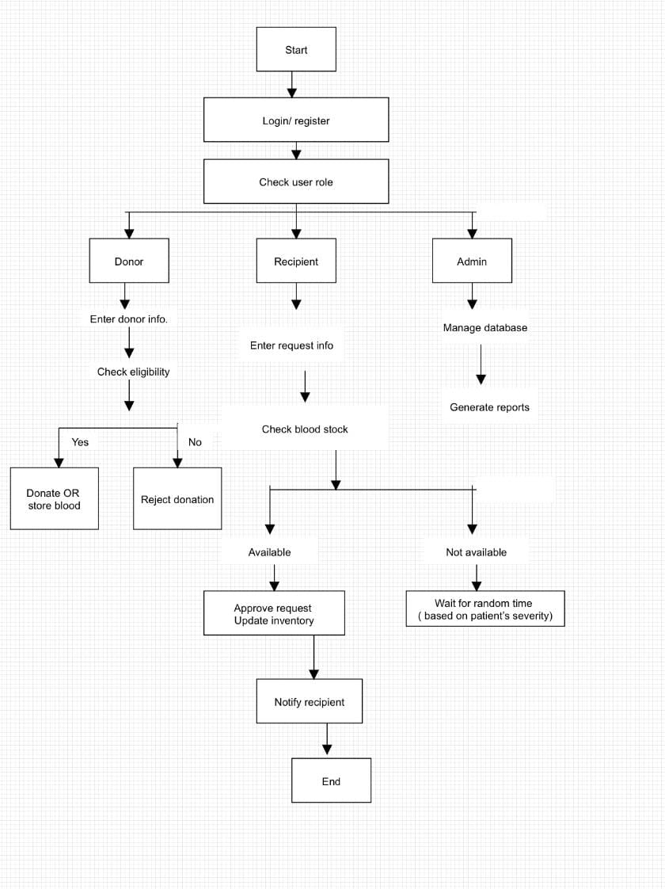
Fig 3.1

3.4 Closure
The methodology followed in this project ensures that the system is developed in a structured and organized way. By focusing on user needs, simple design, and secure data handling, this Blood Bank Management System is aimed at improving the overall efficiency of blood bank operations. The project uses basic but powerful tools to ensure that the system is reliable, easy to use, and can be implemented in small or medium-sized blood banks.

CHAPTER 4

RESULTS AND DISCUSSIONS

4.1 Introduction
The Blood Bank Management System was developed to improve the efficiency, accuracy, and speed of managing blood donors, blood inventory, and blood requests. The system aimed to replace manual methods with a digital platform that is easy to use, secure, and reliable. After successful development and testing, the system was found to meet the basic requirements of a small to medium-sized blood bank.

4.2 Key points in Results and Discussion
•Successful-Donor-Management:
The system allows smooth registration and management of donor records. Donor data such as name, blood group, contact, and last donation date can be added and viewed easily. This helps in identifying regular and eligible donors quickly.
•Real-Time-Blood-Inventory-Tracking:
The system accurately tracks the number of blood units available for each blood type. It updates the stock automatically after every donation or issue. This reduces the chances of mismanagement or running out of specific blood types.
•Faster-Blood-Request-Handling:
Blood requests can be created and managed easily by the staff. The system helps in checking the availability instantly, which speeds up the process, especially in emergency situations.
•Security-and-Access-Control:
A login system was implemented to make sure only authorized users can access or update records. This helps protect donor and inventory data from misuse or accidental changes.

CHAPTER 5

CONCLUSION AND FUTURE SCOPE

5.1 Conclusion
The Blood Bank Management System developed in this project provides an efficient and reliable way to manage donor information, track blood inventory, and handle blood requests. It replaces time-consuming manual methods with a digital solution that is faster, more accurate, and user-friendly. The system successfully allows staff to register donors, monitor blood stock in real-time, process requests quickly, and maintain data securely through a login system. Overall, the system helps improve the day-to-day functioning of a blood bank and supports life-saving efforts by making critical blood availability information easily accessible.

5.2 Future Scope
Although the current system meets basic requirements, there is still room for improvement and expansion in the future. Some possible enhancements include:
- Mobile Application: Developing a mobile app version for easier access by donors and staff on the go.
- Automated SMS/Email Alerts: Sending reminders to eligible donors and alerts for low stock directly via mobile or email.
- AI-Based Donor Matching: Using artificial intelligence to match donors based on location, blood type, and donation history.
- Multi-User Roles: Allowing different types of users such as hospital staff, volunteers, and administrators with customized access.
- Integration with Government or Hospital Databases: To ensure real-time data sharing during emergencies.
- Cloud-Based System: Hosting the system on a cloud platform to allow remote access from multiple location

REFERENCES

[1] “ Blood Bank Management and Inventory Control Database Management System” by P. Patel, R. Mehta .Year of publish:2020.

[2]“Design and Implementation of Blood Bank Management System” by A. Joshi, M. Deshmukh. .Year of publish:2021

[3]“Blood Bank Management System: Case Study of Mengo Hospital” by Ashiraf Musanje Tebandeke . Year of publish:2022

Web references
[1]https://www.igi-global.com/chapter/a-blood-bank-management-system-based- internet-of-things-and-machine-learning-technologies/249327
[2] https://www.iiste.org/Journals/index.php/JIEA/article/view/49847
[3]https://www.ijraset.com/research-paper/web-based-blood-bank-management- system-for-efficient-blood-donation-and-distribution

APPENDIX I

PROJECT BASED AWARDS AND ACHIEVEMENTS (if any)
The student need to attach the testimonials of the achievement obtained for the project work at the end of the Appendix II.

PATENT
The students need to write the patent details and attach the testimonial for the same (if any)

COPY RIGHT
The students need to write the copyright details and attach the testimonial for the same (if any).

LIST OF PUBLICATIONS
The students need to write the publications details in IEEE format and attach the entire paper in the final report for the same (if any). -

AWARDS/ACHIEVEMENT IN ANY COMPETITIONS
The students need to write the details of any awards/achievement received relevant to the project work along with the photograph (if any).-

APPENDIX II

PROJECT BASED OUTCOMES
The student need to fill the below table for the outcomes they have gained during the work. These outcomes will vary based on project based learnings.
Outcomes | Agree  (1) | Moderately  (2) | Highly Agree (3)
1. Engineering knowledge: Apply the knowledge of mathematics science engineering fundamentals and an mathematics, science, engineering fundamentals, and an engineering specialization to the solution of complex engineering problems engineering problems. |  | Moderately  Agree
2. Problem analysis: Identify, formulate, review research literature, and analyze complex engineering problems reaching substantiated conclusions using first principles of mathematics, natural sciences, and engineering sciences. |  |  | Highly  Agree
3. Design/development of solutions: Design solutions for complex engineering problems and design system components or processes that meet the specified needs with appropriate consideration for the public health and safety, and the cultural, societal, and environmental considerations |  |  | Highly  Agree
4. Conduct investigations of complex problems: Use research-based knowledge and research methods including design of experiments, analysis and interpretation of data, and synthesis of the information to provide valid conclusions |  | Moderately  Agree
5. Modern tool usage: Create, , select, and apply appropriate techniques, resources, and modern engineering and IT tools including and modeling to complex engineering activities with an understanding of the limitations |  |  | Highly  Agree
6. The engineer and society: Apply reasoning informed by Apply reasoning informed by the contextual knowledge to assess societal, health, safety, legal and cultural issues and the consequent responsibilities legal and cultural issues and the consequent responsibilities relevant to the professional engineering practice | Agree
7. Environment and sustainability: Understand the impact of the professional engineering solutions in societal and environmental contexts, and demonstrate the knowledge of, and need for sustainable development and need for sustainable development. |  | Moderately  Agree
8. Ethics: Apply ethical principles and commit to professional ethics and responsibilities and norms of the engineering practice |  | Moderately  Agree
9. Individual and team work: Function effectively as an individual and as a member or leader in diverse teams and individual, and as a member or leader in diverse teams, and in multidisciplinary settings |  |  | Highly  Agree
10. Communication: Communicate effectively on complex engineering activities with the engineering community and with society at large, such as, being able to comprehend and write effective reports and design documentation, and write effective reports and design documentation, make effective presentations, and give and receive clear instructions |  |  | Highly  Agree
11. Project management and finance: Demonstrate knowledge and understanding of the engineering and knowledge and understanding of the engineering and management principles and apply these to one’s own work, as a member and leader in a team, to manage projects and in multidisciplinary environments. |  |  | Highly  Agree
12. Life-long learning: Recognize the need for and have the Recognize the need for, and have the preparation and ability to engage in independent and lifelong learning in the broadest context of technological change |  |  | Highly  Agree

